##### **Dining Chair**

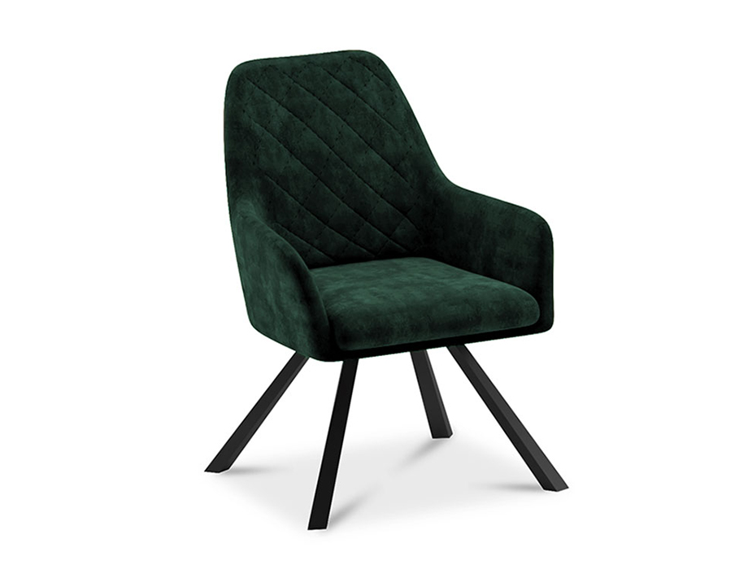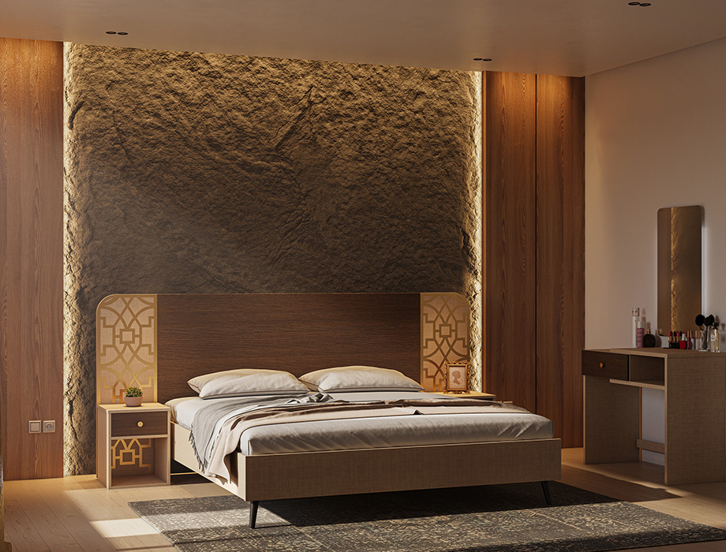

Rocco in Bottle Green Velvet

### **Specifications:**

* **Sizes:**
  + **1 x Bed Size:** 107 W | 80 D | 47 H (Inches)
  + **2 x Bedside Table Size:** 16 W | 20 H | 16 D (Inches)
  + **1 x Dresser Size:** 39 W | 33 H | 19 D (Inches)
  + **1 x Mirror Size:**20 W | 1 D | 35 H (Inches)
* **Material:**MFC Board
* **Legs:** Black Painted Beech Wood
* **Finish:** Dark wenge with fabric texture accentuated with golden acrylic mirror pattern
* **No. of Drawers:** 01
* **Knob Finish:**  Golden
* **Slat-Support:** MDF
* **Mattress:** Not Included
* **Recommended STD King Mattress size:**78 L | 72 W | 8 H (Inches)

Sleek, streamlined and inviting, our Nelson bed set is best known for its elegant design and luxurious beauty. Guaranteed to add a glamorous touch into any interior setting, the large rectangular headboard with its smooth curved corners features meticulous details in dark wenge with a fabric textured finish and a golden acrylic mirror pattern on both sides. The black painted beech wooden tapered legs give lasting stability while the slat-support system offers increased support and strength making it durable for years to come. Minimal and sophisticated bedside tables and a dresser (with single storage drawer, easy-closing channels and golden finished knob) are perfect for storing bedroom essentials. A frameless mirror with smooth round corners completes the dresser's overall design while giving your bedroom a chic and contemporary feel.